Kilmersdon Parish Council
M I N U T E S
Annual Council Meeting held 8th July 2025
In attendance:
Cllrs Ham, Hudson, Lucas, Fowler, Cook
Clerk to the Council Jen Gregory

Public Forum
No matters raised:

25/26 014 Apologies for absence
Cllr Hill-Murray had a previous engagement.
Resolved: Apologies accepted

25/26 015 Declarations of Interest
None.

25/26 016 Minutes
Minutes of the Full Council meeting held 10th June were approved as a correct record.
Resolved: Minutes duly signed in the presence of the meeting.

25/26 017 Matters Arising
From the previous minutes – to include updates on following;-
Community Speedwatch – Three further volunteers have signed up. There has been some issues with the training with a wrong link provided by the Local Co-ordinator. There has been some frustrations resulting in a drop out of 2 volunteers. Nevertheless there is enough to commence a group and progress is being made
School Questionnaire - With the school collect around 18th July
Trees and TPO – Two quotes received a further to be obtained. Given timescales and availability a decision may be needed as a round robin.
Banking admin update – Clerk to prioritise this month
Bridleway Sign Church St 80052 – No update online (medium priority)
Grit Bin and shovel – One bin completed 2nd awaiting installation no urgency currently
Charlton Lane – Signage that was leaning had been reset
Dropped kerb – £750 in application fees so far. Contractors being approached for quotations. Clerk to look at accessibility options with Somerset and using our two Councillors to provide information.
VE Celebration Lady – Installed and a planter to be sourced
Bin Costs – Appears we are being collected. We will wait and see outcome. However SH happy but we should provide PPE.
Bench Costs – Clerk to ask White Horse housing of its whereabouts.
Signage – Circulate options
Highways – Some patching of the areas reported had been carried out with further marked up areas for action
Jack and Jill Hill – finally completed
Request by Cllr Hudson to cut the verge on the other side of the roadside hedge of the village car park. – LSJ Instructed

25/26 018 Councillor Items (Matters raised by Councillors that do not appear elsewhere on the agenda)
Cllr Fowler would provide photos of hedges (tenanted properties of White Horse) where trees/hedges were overlapping the pavements and walking area. Mindful of older residents with walking aids. Clerk would address with White Horse Housing on receipt of details.

The “Chase the Sun” bike-ride had left lots of litter. Clerk to contact organisers with comments.

Trees belonging to the school were encroaching on other properties. Clerk would contact School.

25/26 019 Somerset Councillor Report
Lengthy report too large to display in noticeboard. Clerk picked a couple of interesting/more relevant pages to post up

25/26 020 Finance
Payee | Detail | Gross | VAT | Net
J Gregory | Salary | 445.90 |  | 445.90
K Harvey | Internal Audit | 150.00 |  | 150.00
LSJ Gardening | Grasscutting Inv 1120 | 238.00 | 39.67 | 198.33
LSJ Gardening | Grasscutting Inv 1128 | 238.00 | 39.67 | 198.33
K Village Hall | June Rental | 20.00 |  | 20.00
- Approve payments to be made

- Reconciliation of Bank Account to Cashbook deferred to August due to Clerk annual leave and jury service restricting time this month

Resolved: Proposed Cllr Hudson, Seconded Cllr Fowler to agreed the above payments along with a payment to S Horler for £675.00 and Cllr Fowler for Postcrete reimbursement. Payments made by Cllr Hudson in the presence of the meeting.

25/26 021. Planning
- Planning Applications Received

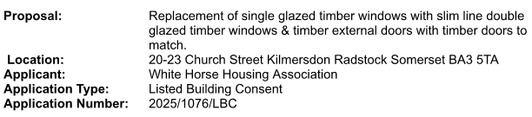

Resolved: The Council have no objection to the above application

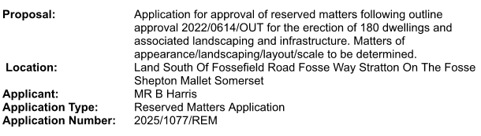

Resolved: Lengthy discussions given this was for reserved matters following outline approval. It would be hard to pin point any particular element of appearance, or infrastructure without having the expertise. Given outline planning has been granted, Council requested that the rural aspect of the site be maintained with lots of trees and planting retaining as much eco-systems as possible.

Application | Location | Works | KPC - Decision | SC - Decision
2024/1521/LBC | Charlton Inn Cottage -  Charlton Rd to Kilmersdon Hill | Boundary wall repairs and render to side elevation | Recommend approval (decision via email) | Approval
2024/1232TCA | Manor Farm Tumblers Bottom | Fell Trees | Recommend Approval | Approval
2024/0447/OUT | Land At Old Redhouse Farm | 1 Detached and terrace of 5 | Recommend Rejection | Rejected
2024/0856/HSE | 4 Silver Street | 2 storey extension | No comment | Approval
2022/1028/FUL | Land adjacent to Sunlea, Fosse Way | Erection of dwelling | No comment | Decided  Approval
2024/0923/TPO | Babington House | Copper Beech – height reduction | No comment | Decided  Approval
2024/0856/HSE | 4 Silver Street | 2 story extension | No comment | Registered
2022/0614/OUT | Land South of Fossefield Road, Fosse Way, Stratton On The Fosse | Application for Outline Planning Permission for erection of up to 180 dwellings | Oppose | Pending -  Rejected at Planning Committee 06.08

25/26 022 Reports
Financial Regs – to update following move to Unity.

25/26 023 Items for Next Meeting
Discussion of play questionnaires and feedback
Surgery autumn date: ideas around the shop, invitation to Persimmon to attend September meeting.

25/26 024 Parish News Items
Continued recruitment drive for CSW
Installation of VE 80 Lady (picture)
Address bike ride litter
Hedges and overhanging
Dropped kerb idea

25/26 025 Correspondence
Nothing further to report

25/26 026 Next Meeting Date
Normally not held but a short meeting to focus and keep pace with items requiring discussion to be held 12th August.

Meeting closed at 9.55pm

All members thanked for their contribution and efforts.

A signed copy of the minutes can be obtained from the Clerk.

